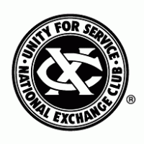

CALIFORNIA-NEVADA DISTRICT EXCHANGE CLUBS

FINANCIAL REPORT THROUGH MARCH 14, 2025
STRATEGIC ACTION and GROWTH PLAN
Administrative Year 2024 / 2025

Prepared by
Ken DuFour – District President
JP Fallou - District President-Elect
Johnny Tai – District Secretary
Bonita Gibson – District Treasurer

Updated for period ending on March 14th, 2025

Table of Contents
District Executive Summary 3
Admin Year 2023 – 2024 Results 3
Current Status – Q2 5
Finance Results – March 14th, 2025 5
Balance Sheet 5
Profit and Loss 6
Current District Structure 7
Q2 Member Results through Feb 28th, 2025 7
Proposed Developments 8
Strategic Action Plan Initiatives for Admin Year 2024/2025 9
1) Assess Current Membership – Completed. Results pending. 9
2) Set Clear Goals 9
3) Enhance Member Engagement 9
4) Improve Recruitment Strategies 9
5) Offer Value-Added Benefits 10
6) Streamline the Membership Process 10
7) Strategic Opportunity to Consider increasing Membership 10
8) Monitor and Adjust 12
9) Celebrate Successes 12
SWOT Analysis 13
SWOT – District & Club Overall View 13
SWOT – District & Club Leadership 14
SWOT – Existing Clubs 14
SWOT – Rebuilding Understrength Clubs 15
SWOT – Membership 15
SWOT – Building New Clubs 16
SWOT – Marketing/PR 16
GPS (Goals, Priorities and Strategies): 17

District Executive Summary

The California-Nevada District Exchange Clubs is a part of the National Exchange Club, encompassing clubs in Mid and Southern California as well as Southern Nevada. The Northern California District, established in the mid-1990s, covers the northern parts of both states. At its peak, there were nearly 150 Exchange Clubs throughout California, with several in Nevada, including at least three in Las Vegas, one in Reno, and one in Lake Havasu.

Many of the clubs in the district are largely understrength and lack any initiative to rebuild their clubs and find prospects to join, nor build new clubs. The most recent club chartered in the District was the Tustin Exchange Club in November, 2015. The former Internet Club of Exchange has been renamed the Exchange Club of Las Vegas. The largest clubs in the District are Culver City, San Ramon Vally, Newport Harbor, Porterville, Hemet-San Jacinto Valley, Kern Valley, and Gilroy which have between 30-62+ members.

For the past several years, the District has been faced with several critical issues which includes rebuilding understrength clubs, retention of new members and building new clubs that are necessary for the survival of not only this District but for the Districts across the United States and Puerto Rico. These issues should be prioritized and carried forward into objectives each year as the District comes under new leadership.

Admin Year 2023 – 2024 Results
During our Administrative Year 2023 / 2024 and as reported on July 1, 2024, the District had 26 clubs. Through June 30th, our membership total was 538. We welcomed 69 new Exchange Members and bid farewell to 84 Members, so our membership is down by 15 members. The Exchange Club of Long Beach gave up their charter after 103 years on April 30th because no one wanted to take on the leadership role and they had no new members.

Twelve clubs maintained their membership levels: Bakersfield, Downey, Fontana (up and down 2), Fresno, Hemet, Hollister, Laguna Beach, San Diego, San Jose, Scotts Valley, Pacific Coast, and Tustin. Five clubs experienced a net loss in membership: Cuyama Valley, Irvine, Las Vegas, San Ramon Valley, and Excel Club Granite Hills High School. Most losses were minor, except for Cuyama Valley and the Excel Club, which saw a significant drop from 26 members to just 1.
Nine clubs saw a net increase in membership: Culver City, Kern Valley, Newport Harbor, Porterville (41% gain), Magnolia Center - Riverside, San Clemente (27%), Central Coast, Gilroy (35%), and South Orange County (21%).

Seven clubs have fewer than 10 members, including the Excel Club with only 1 members. Eleven clubs have between 10 and 29 members, and eight clubs have over 30 members. One club has over 50 members: Culver City, the largest, with 62 members, followed by San Ramon Valley with 43 and Newport Harbor with 41. The club with the most growth was Porterville, which increased by 11 net members.

Current Status – Q2

Finance Results – March 14th, 2025

Balance Sheet

Current period shows Assets as follows. 1)Bank accounts are $74,422.00 between three checking accounts with our QuickBooks Checking account earning 3.00% interest. As we transfer some of our General Funds to the QuickBooks reserve, the district will continue to earn interest of those funds. Accounts Receivable are $2,803.00 with check waiting to be deposited into our account. Exchange Club of Fresno has an outstanding balance of $2,160. Liabilities are $0.00 for a Total Liabilities and Equity at $77,225.00.
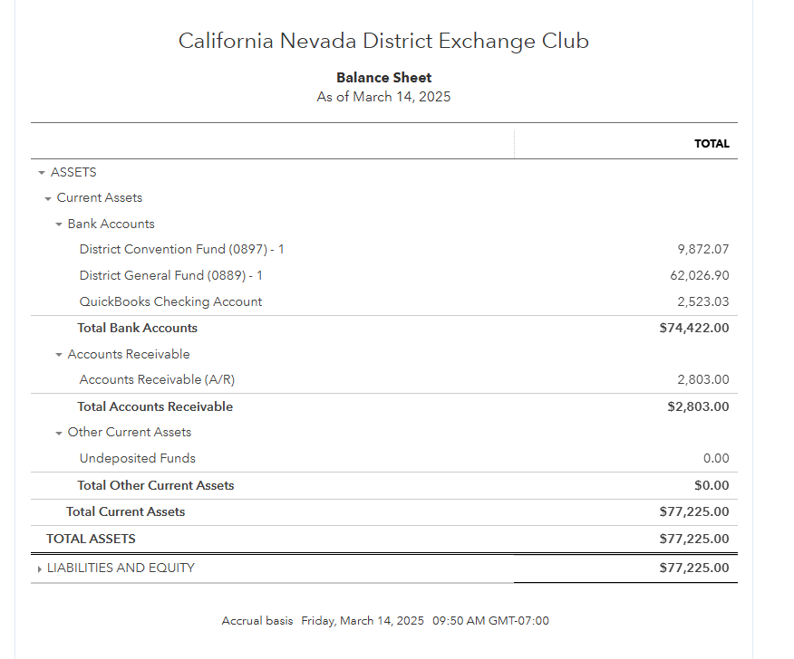

Profit and Loss

The district generated a total income of $16,376.00, primarily from membership fees and convention fees. The total expenses amounted to $13,986.40, with significant costs in Donations, meals & entertainment, and Officer Stipends.

Net Operating Income: After deducting expenses from the gross profit, the net operating income is $2,389.60. The net income, which is the final profit after all expenses, is also $$2,389.60.

.

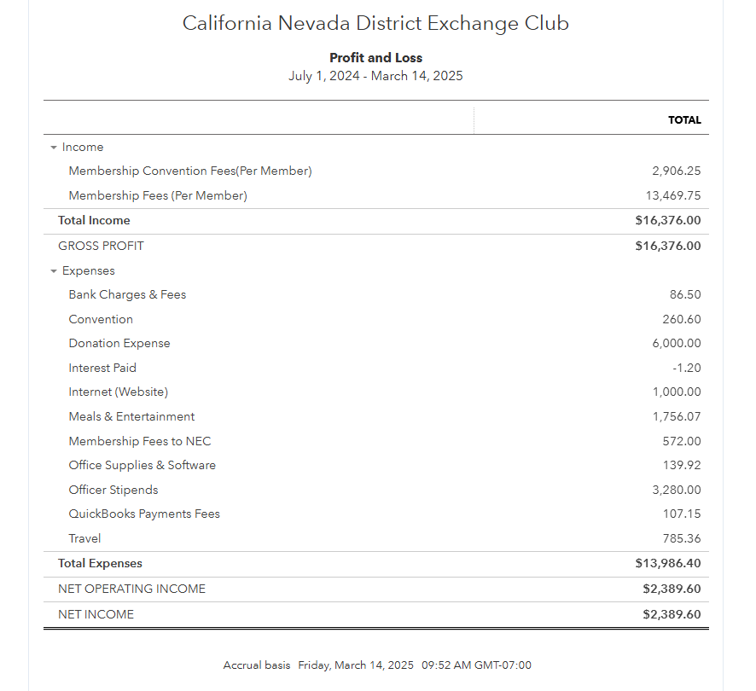

Current District Structure

The District’s organizational structure consists of a President, President-Elect, Immediate Past President, Secretary and Treasurer that make up the Executive Committee. The Board of Directors consists of at least seven directors called District Directors that represent the clubs in certain divisions inside the District Boundary. The district has a Chief Operating Officer that holds a district board seat. That brings our total to 11 board members. The board of directors typically meets at a minimum on a quarterly basis with an annual convention held in the last quarter of our administrative year.

We have established a Training/Education Session for all District and Club Officers, scheduled for the third Thursday of the first and second month of each quarter. Each session will cover the roles and responsibilities of District Directors and Club Officers, including specific training on our Award programs, fundraising ideas, and the overall state of the district. These sessions aim to help our clubs retain and build membership plus enhance communications across the clubs and our district.

Q2 Member Results through Feb 28th, 2025
We have experienced a decline in membership in some clubs with a reduction of 53 members. This trend is largely due to factors such as members passing away, relocating, health issues, and other commitments, which is reflective of our aging clubs. We do see some clubs continuing to decline and or simply going away.

However, some clubs are seeing growth by actively recruiting through word of mouth, social media, and partnerships with both non-profit and for-profit businesses. Overall, we welcomed 57 new members and 30 Excel Members to include five new business memberships, resulting in a net increase of 4 members.

We anticipate the Exchange Club of Tustin and Exchange Club of Fresno to turn in their charter this next quarter for a drop of membership of approximately 31 members.

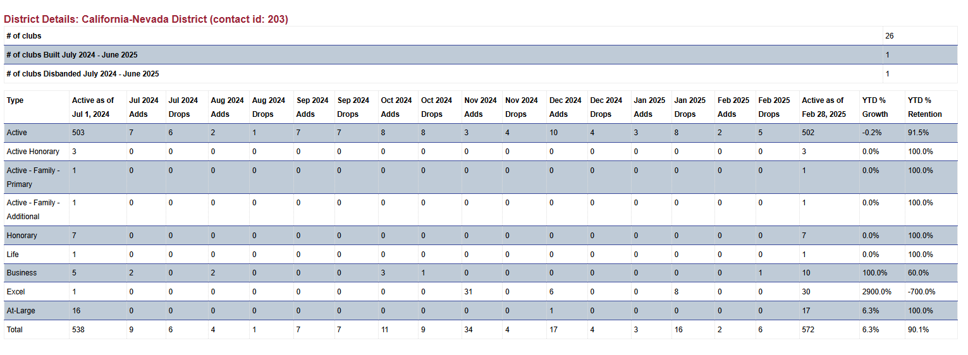
In order to continue making a meaningful impact in our communities, it is crucial that we remain vigilant in our efforts to grow our membership. By actively seeking new members and fostering strong relationships with businesses and individuals alike, we ensure that our club remains vibrant and capable of addressing the needs of those we serve. Growth not only brings fresh ideas and energy but also strengthens our ability to achieve our mission and sustain our initiatives for years to come. We are committed to this shared goal and work together to build a stronger, more dynamic service club.

Proposed Developments

- In addressing some of these issues, recently the district is considering the position of the President become a two-year term as opposed to the one-year term for at least the next two cycles because this allows the leadership more time to work on the challenges of the District and gives more time for the President-Elect to prepare in his or her role moving forward.
- Make recommendations for Corporate/Business Membership types at the National Exchange Club. We are observing some clubs successfully integrating both non-profit and for-profit memberships to create a collective expertise of peers, fostering leadership excellence, and advancing our four areas of interest. These businesses are actively involved in the community, making Membership into a club a key focus. Given that some of our business/corporations are sponsoring our events, we see the value in encouraging them to take an active role in our community and our local club.

Strategic Action Plan Initiatives for Admin Year 2024/2025

Creating a strategic plan to build membership for the California/Nevada Exchange Club involves several key steps that we are implementing this administrative year. Here’s a comprehensive approach:

Assess Current Membership – Completed. Results pending.
  - Survey Members: Conduct surveys to understand current members’ satisfaction and gather feedback on what they value most about the club.
  - Analyze Trends: Review membership data to identify trends in retention and attrition as we have done in the Executive Summary above.

Set Clear Goals
  - Realign and Train District Directors: Revise District Divisions from 7 to 6. Train District Directors on a regular basis to provide maximum support from leadership and to the local clubs.
  - Membership Targets: Define specific, measurable goals for membership growth (e.g., increase by 10% annually).
  - Diversity Goals: Aim to diversify membership by age, profession, and background to reflect the community better.

Enhance Member Engagement
  - Regular Events: Host engaging events, both social and professional, to keep members active and involved.
  - Volunteer Opportunities: Create meaningful volunteer opportunities that align with members’ interests and skills.

Improve Recruitment Strategies
  - Referral Programs: Encourage current members to refer new members by offering incentives.
  - Community Outreach: Increase visibility through community events, partnerships, and local media.
  - Online Presence: Optimize the district’s website and social media for new member and club conversions.

Offer Value-Added Benefits
  - Professional Development: Provide workshops, seminars, and networking opportunities.
  - Exclusive Content: Offer members-only content such as newsletters, webinars, and access to industry experts on a local or National basis.

Streamline the Membership Process
  - Simplified Joining Process: Make it easy for new members to join through an intuitive online application process.
  - Welcome Packages: Provide new members with welcome packages that include information about the club and upcoming events.

Strategic Opportunity to Consider increasing Membership
  - Convert Sponsors into Business Memberships: Many clubs have sponsorships from Business within the community. Converting business sponsorships into business memberships can be a strategic way to grow your club. Here are some steps to help us achieve this approach.
    - Identify Mutual Benefits
      - Highlight Value: Clearly communicate the benefits of membership, such as networking opportunities, community involvement, and brand visibility.
      - Tailored Packages: Create membership packages that align with the sponsor’s business goals and interests.
    - Build Strong Relationships
      - Personal Engagement: Engage with sponsors personally through meetings, events, and regular communication.
      - Exclusive Events: Invite sponsors to exclusive events where they can see the value of being more involved.
    - Showcase Success Stories
      - Case Studies: Share success stories of other businesses that have benefited from membership.
      - Testimonials: Use testimonials from current business members to highlight the positive impact of membership.
    - Offer Incentives
      - Discounts and Perks: Provide special discounts or perks for sponsors who become members.
      - Recognition: Offer public recognition in newsletters, on the website, and at events.
    - Leverage Existing Sponsorships
      - Cross-Promotion: Use existing sponsorship agreements to promote membership benefits.
      - Bundled Offers: Create bundled offers that include both sponsorship and membership benefits.
    - Demonstrate ROI
      - Metrics and Reports: Provide regular reports showing the return on investment (ROI) for their sponsorship and potential ROI for membership.
      - Impact Analysis: Show how membership can enhance their brand’s impact in the community.
    - Create a Seamless Transition
      - Easy Conversion Process: Make the process of converting from a sponsor to a member straightforward and hassle-free.
      - Dedicated Support: Assign a dedicated team member to assist sponsors in transitioning to membership.
    - Follow Up
      - Regular Check-Ins: Maintain regular contact with sponsors to keep them engaged and informed about membership opportunities.
      - Feedback Loop: Gather feedback from sponsors to continuously improve the membership conversion process.
  - Convert a Non-Profit Organization Partners into a Exchange Club Memberships.
    - Community Engagement
      - Non-profits are often deeply embedded in the community, understanding its needs and challenges. Their involvement helps the Exchange Club identify and address local issues more effectively.
    - Resource Sharing
      - Non-profits bring valuable resources, including expertise, volunteers, and funding opportunities. This collaboration can enhance the club’s ability to execute projects and initiatives.
    - Networking Opportunities
      - Partnering with non-profits expands the club’s network, connecting members with other organizations and individuals who share similar goals. This can lead to new partnerships and collaborative efforts.
    - Credibility and Trust
      - Non-profits often have established reputations and trust within the community. Their association with a Exchange club can enhance the club’s credibility and attract more members and supporters.
    - Diverse Perspectives
      - Non-profits bring diverse perspectives and innovative ideas to the table, enriching the club’s approach to problem-solving and community service.
  - By integrating non-profits into our Exchange club operations as members, Exchange Clubs can significantly amplify their impact and effectiveness in serving the community.

Monitor and Adjust
  - Regular Reviews: Continuously monitor membership data and adjust strategies as needed.
  - Feedback Loops: Establish regular feedback loops with members to ensure their needs are being met and to gather new ideas.

Celebrate Successes
  - Recognition Programs: Recognize and reward members for their contributions and milestones.
  - Public Acknowledgment: Highlight member achievements in newsletters and on social media.
By implementing these strategies, we can effectively convert member recruitment and business sponsorships into long-term memberships, fostering a stronger and more engaged community.

SWOT Analysis

Taking into consideration the strategic action plan initiatives, the district is investigating a SWOT analysis (Strengths, Weaknesses, Opportunities and Threats) of its current situation and how it may affect the District and our clubs over the next three years.

SWOT – District & Club Overall View

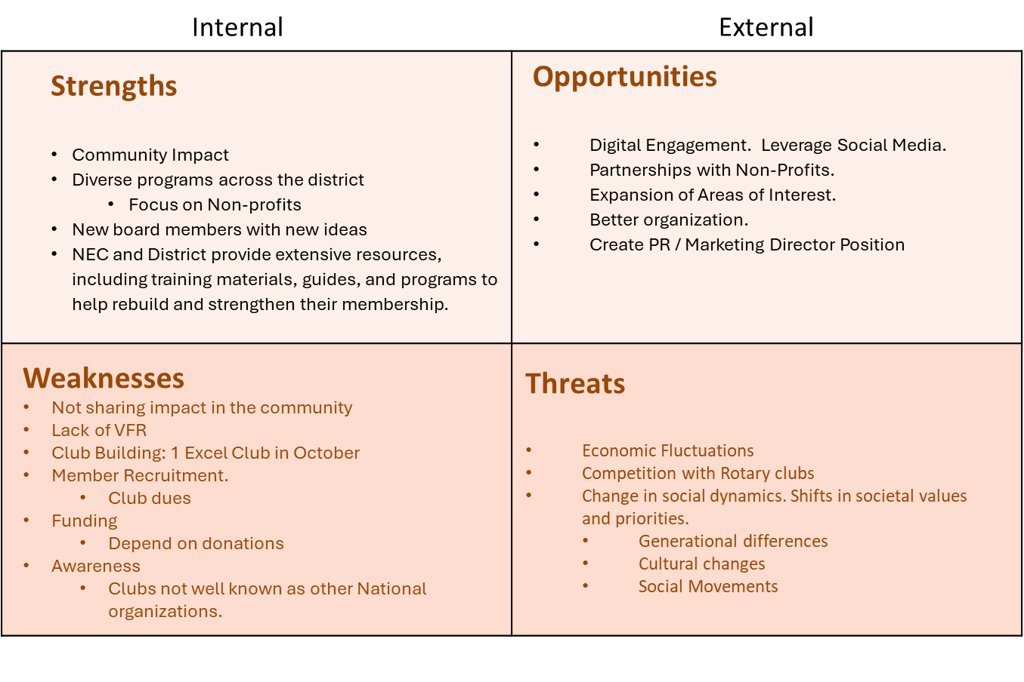

SWOT – District & Club Leadership
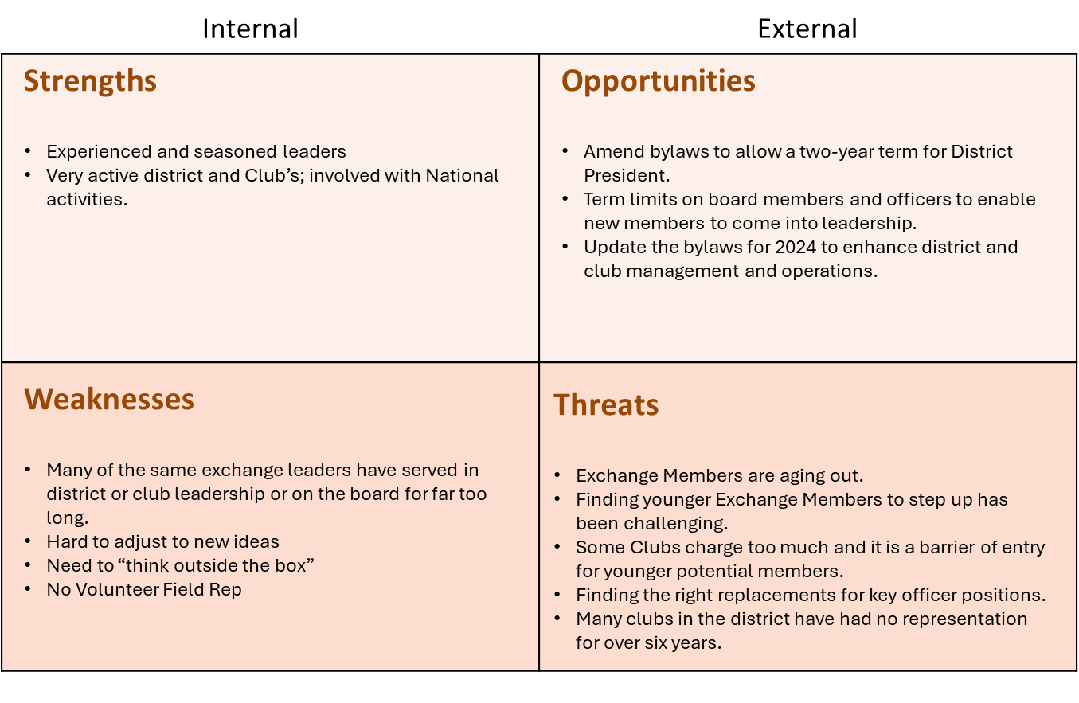

SWOT – Existing Clubs
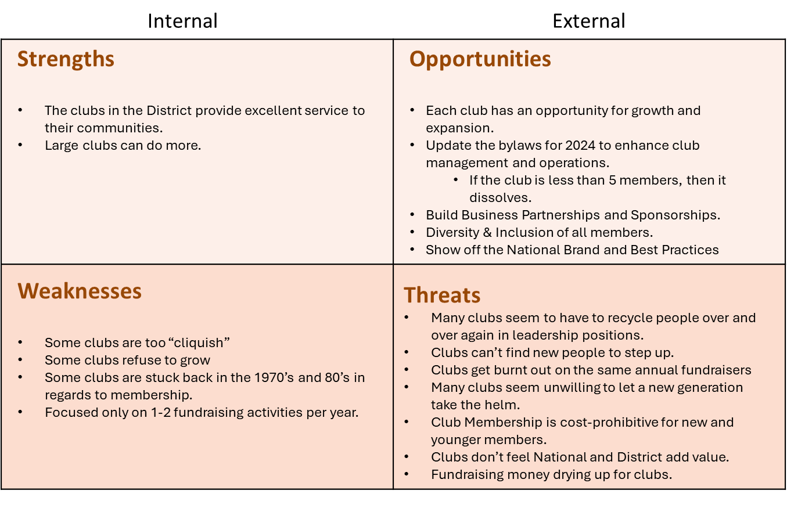

SWOT – Rebuilding Understrength Clubs

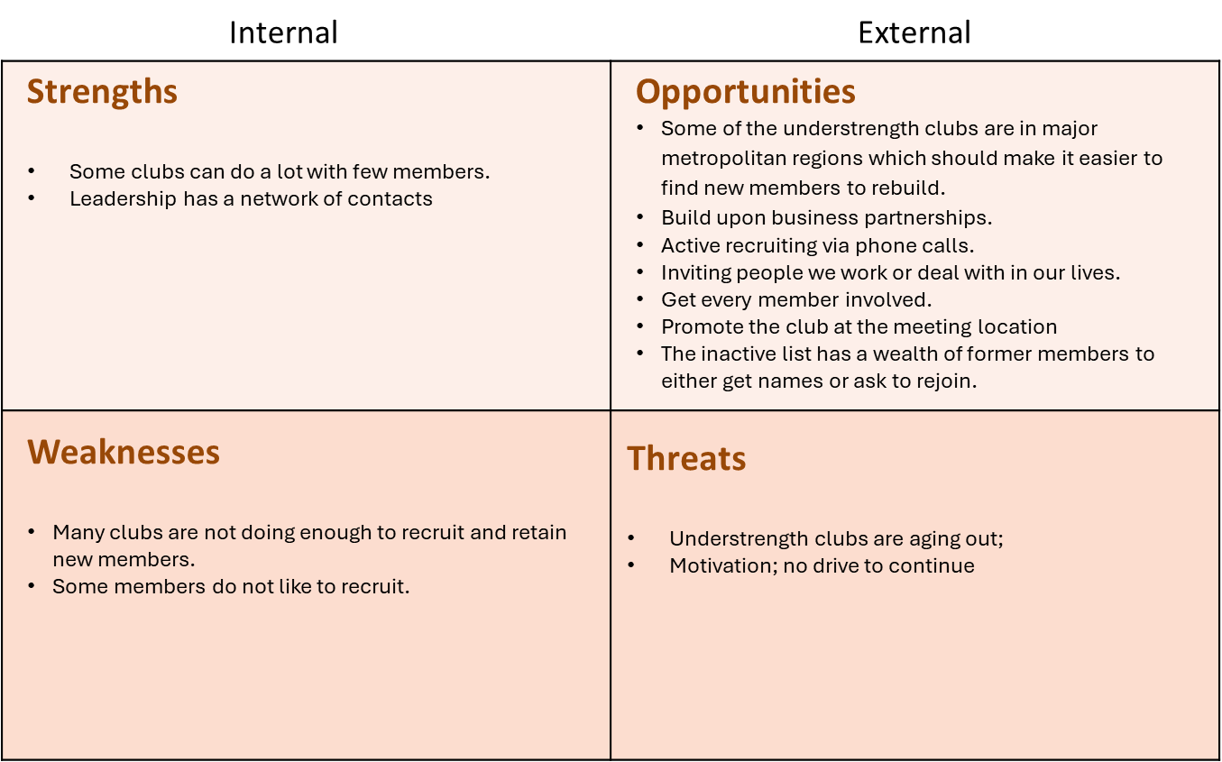

SWOT – Membership

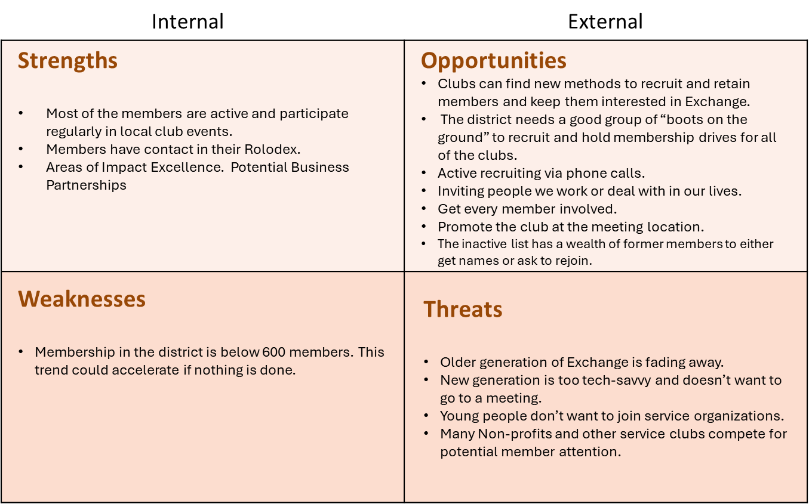

SWOT – Building New Clubs

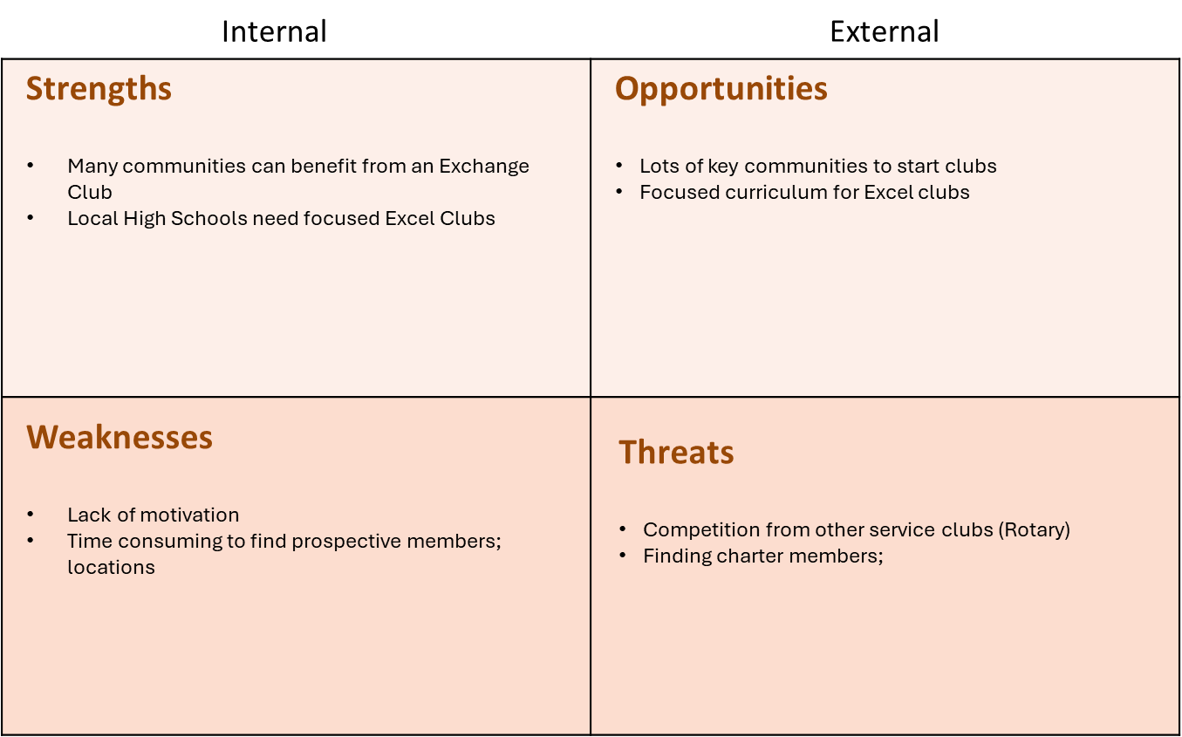

SWOT – Marketing/PR

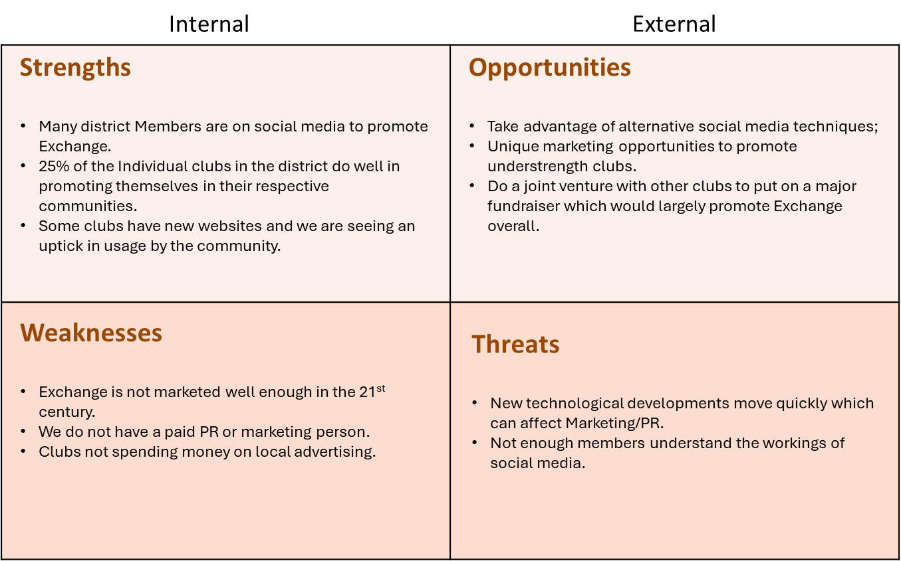

GPS (Goals, Priorities and Strategies):

The district should set goals of at least three years out and how to prioritize those goals with effective strategies. Who will the action team members be to bring those goals into fruition and what the estimated costs will be for those goals. There should be progress reports on these goals.
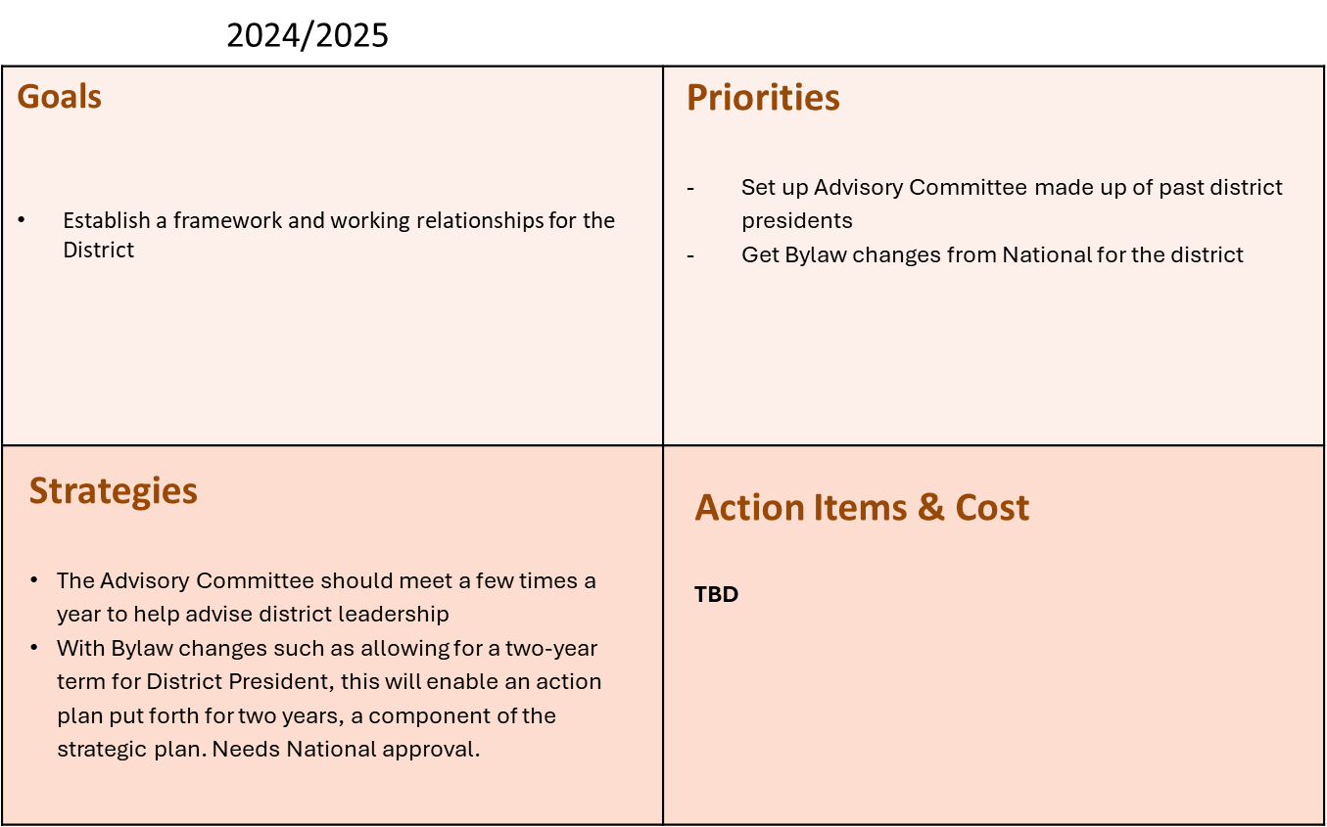

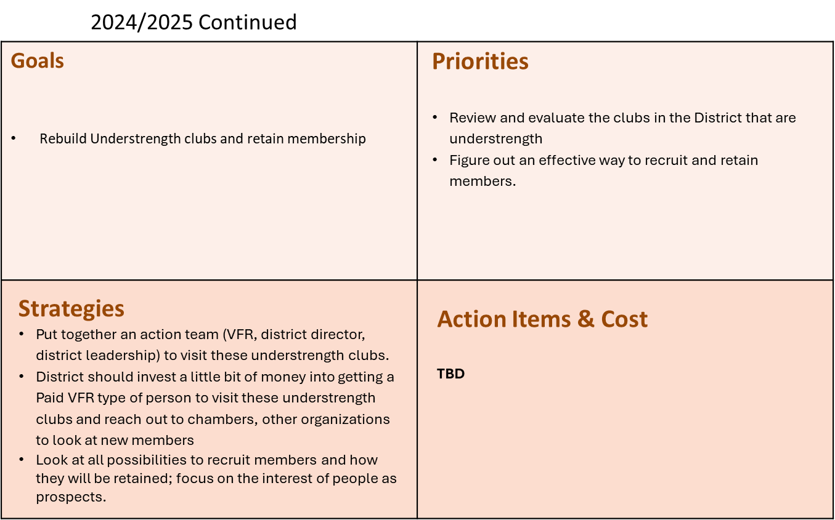

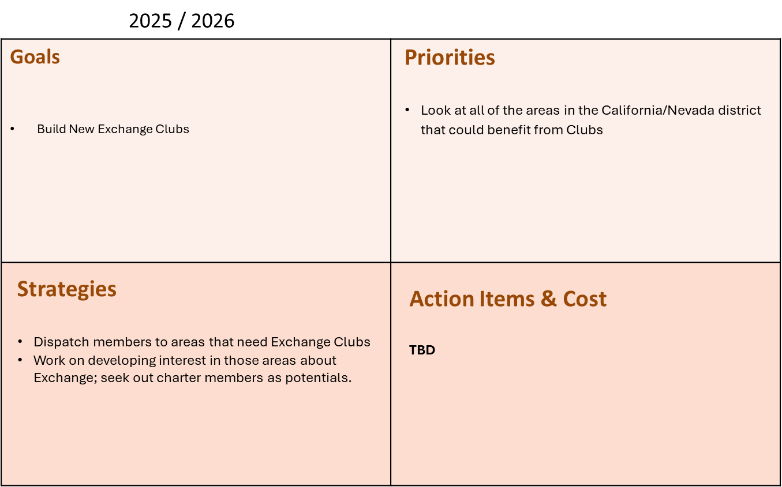

Financial Plan: District needs to invest some funds to recruit a kind of district and/or regional Volunteer Field Representative. This will help pay for travel to recruit members and build and/or rebuild clubs. Is there grant funding that we can apply for and earmark funding for this area?

Operational Plan: District Leadership and Board of Directors will be responsible for the operating plan moving forward and that areas are prioritized.

Resources: National Exchange Club; begin aggressively using our partnerships with National Non-Profit organizations for outreach to other communities across the Nation that are not familiar with Exchange to engage them. Social media should also be used as a resource and to engage and brand the National Exchange Club as a major national service organization.

Evaluation: The plan should be evaluated every year to make sure it continues to move forward and not pushed on the wayside.

