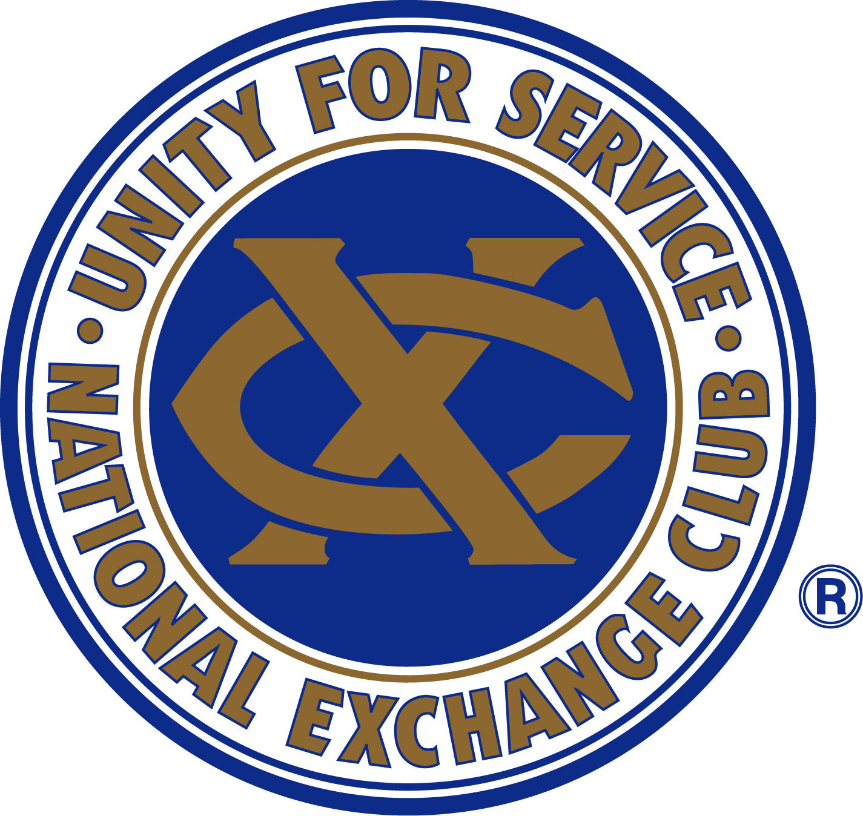
Exchange Club of Newport Harbor
5th Grade Patriotic Art Program 2025 - 2026
“Celebrating America”

By participating in a Patriotic Art Award contest, students not only develop their artistic abilities but also gain a greater appreciation for their country and the freedoms and opportunities it provides.

THEME – “Celebrating America”

DUE DATE – March 13, 2026. Contact Cynthia Strasmann to arrange delivery.

RULES & GUIDELINES – Please review thoroughly.
- Original Artwork: Each student must create their own original artwork.
- Judging Criteria: Entries will be judged on originality, presentation, patriotism, relevance to the theme, clarity, total impact, and uniqueness.
- Patriotic Theme: Projects must reflect the theme “Celebrating America.” Celebrate what makes America special—its history, symbols, heroes, values, and the diverse people who make our communities strong. Students can depict freedom, unity, courage, or the future of our nation. Use your creativity to share your personal vision of the spirit of America!
- Approved Materials: Students may use pencils, markers, colored pencils, colored pens, and crayons. Paintings are not allowed.
- Provided Material: The Exchange Club will supply 18” x 24” paper. All entries must be submitted on this material in landscape (horizontal) orientation.

PROHIBITED ELEMENTS
Artwork will be disqualified if it includes any of the following:
- Gory details (e.g., blood, knives, guns, dead bodies)
- Incorrect size or orientation
- Political statements

SUBMISSION REQUIREMENTS
- Identification: Students must write their first and last name, and school name on the back of the artwork, clearly and legibly.
- Lamination: Participating schools must laminate all artwork before submission, leaving a ½ inch border around the artwork.
- Provide an Excel spreadsheet listing students’ names and email to Cynthia Strasmann.
- Artwork must be submitted to the Exchange Club of Newport Harbor by March 13, 2026.

JUDGING
The Exchange Club will judge the entries and award the top four students – 1st – 4th.

FIELD OF HONOR
All student artworks will be displayed at our annual Field of Honor event from May 15 to May 25, 2026.

STUDENT RECOGNITION | FLAG DECK
Please provide a date and time for us to attend a Flag Deck in mid-April – early May to honor your winning students.

FIELD OF HONOR STUDENT PROGRAM
The 1st place winners from each participating school will be entered into our Ultimate Field of Honor Patriotic Art Contest. The top three winners must attend the ceremony at Castaways Park in Newport Beach on Thursday, May 21st.

RETURNED ARTWORK
All student entries will be returned at the beginning of June – before the end of the school year.

QUESTIONS: Please contact Cynthia Strasmann at Cynthia.Strasmann@gmail.com or via cell at (949) 351-7192.

